**Lesson 7.4: How the Internet Works**

*Break into POGIL teams of 4. Each team member should take the following roles.*

|  |  |  |
| --- | --- | --- |
| **Student Name** | **Role** | **Responsibility** |
|  | Facilitator | Records the team’s predictions and observations. |
|  | Spokesperson | Reports the team’s results and conclusions. |
|  | Quality Control | Validates the team's results and conclusions. |
|  | Process Analyst | Keeps track of the team’s progress and assesses its performance. |

**Activity 1 - Using Ping to Test the Reachability of Internet Hosts**

The [CentralOps.net](https://centralops.net/) has free interactive tools that can be used to observe packet routing, latency time, and other Internet statistics. Just choose the tool you want to use from the navigation bar on the left.

Ping tests whether a host computer is reachable by repeatedly sending data packets from the CentralOps.net server in Dallas, TX to the host computer.

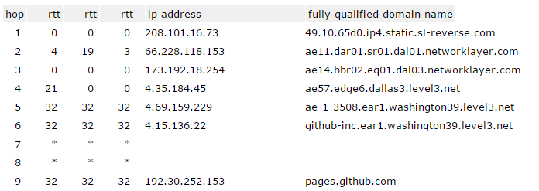

* *Hop Number* - This is the first column and is simply the number of the hop along the route. In this case, it is the tenth hop.
* *RTT Columns* - The next three columns display the round trip time (RTT) for your packet to reach that point and return to your computer. This is listed in milliseconds. There are three columns because the traceroute sends three separate signal packets. This is to display consistency, or a lack thereof, in the route.
* *Domain/IP columns* - The next column has the IP address of the router. If it is available, the domain name will also be listed.

1. For each of the following servers, write down the average round trip time (RTT):
   1. Google.com
   2. Yahoo.com
   3. www.trincoll.edu
   4. appinventor.mit.edu
2. Did any of the servers lose packets? Packets are lost if there are asterisks in the RTT columns. For example, packets sent for hop’s 7 and 8 in the above image were lost.

**Activity 2 - Using Traceroute to Observe How Packets are Routed**

1. Traceroute lets you trace the route from the CentralOps.net server in Dallas, TX to some destination server. Use Traceroute to identify the IP addresses and trace the routes to the following host computers: google.com, yahoo.com, www.trincoll.edu, appinventor.mit.edu.
2. Use the [Monitis Traceroute tool](http://www.monitis.com/traceroute) to measure the average latency between various servers on the Internet. How much time (should be listed in the blue tab at the top of the results) and how many hops do the following routes take? Add your own two sites to test.

|  |  |  |
| --- | --- | --- |
| **Domain** | **# of Hops** | **Average Time** |
| http://google.com |  |  |
| http://whitehouse.gov |  |  |
| http://mobile-csp.org |  |  |
|  |  |  |
|  |  |  |

1. Does the average time increase with the number of hops? Why do you think some take longer than others?

**Activity 3 - Packet Sniffers & Public Networks**

Watch this video (<https://youtu.be/b56WwssMxZw>) that describes how a hacker could view your data on a public network using a packet sniffer.

1. When and where do you use public networks?
2. How do you use the Internet on them (i.e. what kind of data are you sending and receiving)?
3. How you might protect your data?

**Activity 4 - Lookup Domain Names & IP Addresses**

Using one of the tools below, look up the IP addresses for various websites, including their subdomains.

1. For each of the sites below, identify the top level domain, a subdomain (if it has one), and then look up their IP address using [WhoIs.com](https://www.whois.com/). Describe the patterns you see between sites with and without subdomains (google.com and maps.google.com).

|  |  |  |  |
| --- | --- | --- | --- |
| **Domain** | **Top Level Domain** | **Subdomain** | **IP Address** |
| google.com |  |  |  |
| maps.google.com |  |  |  |
| wikipedia.org |  |  |  |
| en.wikipedia.org |  |  |  |
| mit.edu |  |  |  |
| appinventor.mit.edu |  |  |  |

1. Write down the IP address for the computer you are using by visiting [WhatIP.com](http://www.whatip.com/). Compare your IP address to another group’s IP address. How is the pattern similar or different than the domain/subdomain pattern from Step 1?
2. Take out a mobile device and connect to your school’s wifi. Use the website <http://touch.whatsmyip.org> to find the device’s IP address. Compare your IP address to another group’s IP address or other members in your own group. Describe any differences or similarities you see to the IP addresses in Step 2.